Anna Moeller

Assignment 5

9/28/15

1. Estimate of mean from MLE: mean = 0.5486868

Estimate of mean from mean() = 0.5486932

Estimate of SD from MLE = 0.1909085

Estimate of SD from sd() = 0.1918524

SE(mean) = 0.2663244

SE(SD) = 0.1884756

Histogram of (runif(0,1) + runif(0,1)) /2

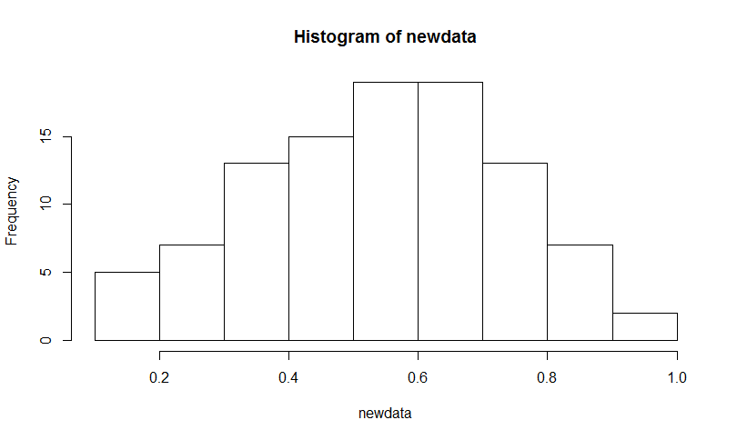

This looks normal!

1. Histogram of data

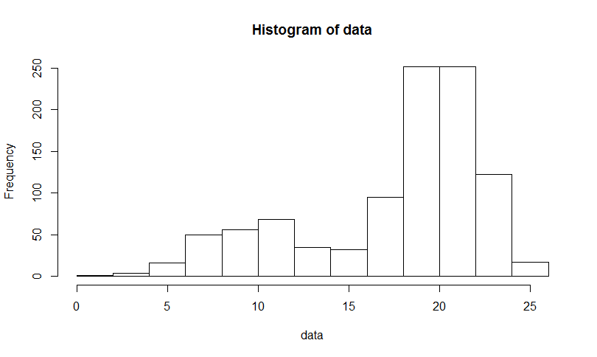

This does not look normal. It looks bimodal or like it has a very long left tail.

Estimate of mean from MLE = 17.553524

Estimate of mean from mean() = 17.55149

Estimate of SD from MLE = 4.967767

Estimate of SD from sd() = 4.975939

These results are very similar. MLE works even though the data do not look normally distributed.

1. When the starting value means are both = 5:
   1. Estimate of means from MLE = 1.534652e+01, -4.595773e+05
   2. Estimate of SDs from MLE = 4.100407e+00, 1.967105e+05
   3. SE(mean) = 0.1517768, 8.491609e-10
   4. SE(SD) = 0.07335504, 1.698322e-09

When the starting value means are both = 25:

1. Estimate of means from MLE = 17.412433, -8312.562210
2. Estimate of SDs from MLE = 4.982579, 4738.161835
3. SE(mean) = 0.1574463, 2.733967e-07
4. SE(SD) = 0.1112885, 3.23581e-07

There are two local maxima, so when the starting value is 25, the computer is stopping when it reaches the right local maximum at 17. When the starting value is 5, the computer is stopping when it reaches the local maximum on the left. Also, the convergence message is 1, which means that it did not converge.